**Tech stocks drive equities gains**

Global equities ended the year on a positive note with gains on the exchanges mainly driven by AI stocks. The “Magnificent seven” stocks delivered outsized gains whilst earnings expectations continue to grow due to economic momentum. In the US, GDP growth averaged 2.6% quarter on quarter annualised over the first three quarters of 2024 and is projected to end the year strongly. Major focus was on the elections which resulted in the re-election of Donald Trump. This brought optimism for deregulation of certain sectors as well as uncertainty over trade tariffs.

In China, economic activity remained weak as the country continues to grapple with falling property prices and weak consumer confidence. The Chinese implemented measures that made equities rally in the second half of the year. Japanese equities were driven by optimism over the end of deflation and the weak Yen.

On the currency front, the USD remained strong against major currencies on the back of the strength of the US economy and a less dovish central bank compared to other central banks. The Yen depreciated 10.47% against the USD despite the efforts by the central bank to end the negative interest rates and raising the short-term interest rates. Over the year, central banks continued to cut interest rates as economies experienced broad based disinflation. Further rate cuts are expected in the coming year as inflation is expected to continue falling.

Gold remained bullish in 2024 registering a gain of 26.36%. Demand for the precious metal was buoyed by central bank buying as diversification from the dollar continues. Demand was also fuelled by growing geopolitical tensions as well as Fed interest rate cuts.

Nickel dropped 7.05% as the metal faced more volatility and uncertainty during the year. Supply for the metal continued to outweigh demand for the metal. Weak economic activity in China, adversely affected demand for the metal. Oil prices declined by 5.32%. According to EIA, strong global growth in production of oil and slower demand growth put downward pressure on prices, while heightened geopolitical risks and voluntary production restrictions among OPEC+ members supported them.

**Global markets performance**



**Source: Online Sources**

**Currency Performance**



**Source: Oanda**

**Commodities**



**Gold Price Performance**

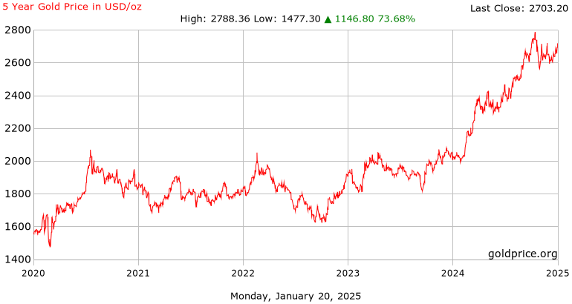

**Source: Goldprice.org**

  **Q4 2024 Newsletter**

**-**

**Quarterly Performance of the ZSE**

|  |  |  |  |  |
| --- | --- | --- | --- | --- |
| **Q1** | **Q2** | **Q3** | **Q4** | **YTD** |
| **Top 10** | **Top 10** | **Top 15** | **Medium Cap** | **All Share** |
| 341.83% | 35.92% | 92.15% | 18.18% | 117.58% |
| **Top 15** | **Top 15** | **Top 10** | **Small Cap** | **Top 10** |
| 330.48% | 32.71% | 91.25% | 0.00% | 115.24% |
| **All Share** | **All Share** | **All Share** | **All Share** | **Top 15** |
| 314.19% | 28.64% | 89.22% | -10.61% | 112.54% |
| **Medium Cap** | **Medium Cap** | **Medium Cap** | **Top 10** | **Medium Cap** |
| 245.09% | 15.80% | 66.31% | -17.20% | 127.60% |
| **Small Cap** | **Small Cap** | **Small Cap** | **Top 15** | **Small Cap** |
| 132.24% | 0.09% | 0.02% | -17.28% | 0.11% |

**Market Capitalisation (assessed using parallel rates)**

**Shares Traded on the ZSE**



**VFEX Market Cap**



**Financial Markets**

**A rally on the ZSE**

The ZSE continued to rally in 2024 with demand being driven by an increase in liquidity on the market. Indices on the stock exchange were rebased in April owing to the introduction of another local currency, the ZWG. Currency depreciation was also a factor that drove momentum on the exchange as investors sought to hedge against value loss.

All Share Index surged 117.58% and the blue-chip Top 10 Index eked out 115.21%. The Medium Cap Index gained 127.60% and the Small Cap Index rose 0.11%. The strong performance on the stock market was anchored by the financial services and consumer staples sector.

Blue chips surged during the first three quarters as investors crowded into the leading names. The market experienced weakness in the last quarter owing to profit taking and slow down in the supply of the local currency.

When assessed using parallel rates, market capitalisation stood at US$1.66 bln compared to US$1.44 bln at the beginning of the year. Cannibalisation of counters continued during the year as Edgars and Bridgeford Capital delisted from the ZSE to relist on the VFEX. During the year, market capitalisation peaked at US$2.63 billion in July.

Over the course of the year, 1.3 bln shares exchanged hands on the floors of the bourse. Offshore investors were net sellers as they sold 247 million shares whilst they bought a total of 25 million shares. Turnover from January to March amounted to ZW$339 billion and turnover from April to December amounted to ZWG1.93 billion.

**VFEX Performance**

On the VFEX, the All share Index gained 4.09%. the index was rebased to 100 in January 2024. This was to cater for the new companies that had migrated from the ZSE during the course of the year. Nonetheless, lack of liquidity remains a constraint on the performance of bourse with most counters trading within a small range. Most counters on the bourse remain undervalued as a result. Edgars listed on the bourse during the year whilst National Foods is set to delist from the exchange in 2025. Market capitalisation stood at US$1.28 billion.

**Outlook**

Growth in 2025 has been projected 6% and is expected to be driven by the recovery of the agriculture and performance of the mining sector as commodity prices are likely to remain firm in the international markets. The country is expecting normal to above normal rainfall in the 2024/25 summer cropping season which could boost output reducing the need for grain imports. Nonetheless, the rainfall patterns thus far have not been supporting of crop production. Most places had early rains, followed by a long dry spell that saw some crops wilting.

On the mining front, the growth projection is exposed to external risks as the weakening of commodity prices could adversely affect performance of the mining sector. Demand for commodities has been weakening as the Chinese economy grapples with the weakening property sector. Furthermore, if there is a trade war between China and US, demand for commodities may decline. Nonetheless, escalating geopolitical tension could continue boosting the performance of gold.

Elsewhere, there is need to improve the manner in which the exchange rate is being managed. It would appear the current approach is hurting business particularly retailers. Choppies recently announced the sell of its Zimbabwe operations and evidently other retailers are struggling to stock. Confidence levels towards the local unit remain low resulting in cash trades in hard currency being the preferred approach. As a result, informal businesses are flourishing at the detriment of established business. Authorities will need to remain aggressive on their current stance of clamping down the informal sector if established retailers are to survive.

The tight liquidity stance again adopted by the RBZ is also doing harm to business. In a bid to curtail speculation, the Central bank increased interest rates. Access to working capital remains a challenge for some business entities. In the past year, we witnessed companies like Beta Holdings and Khaya cement going under judicial management. Treasury together with the Central bank have also been quoted in media circles indicating that government debt will not be honoured on maturity. Word on the market is that government has not been paying its various service providers. All this has seen the sentiment in the business environment becoming negative. Tightening money supply has been used as measure to achieve currency stability and has been seemingly successful in the short run. Money supply is likely to grow as the government honours its obligations.

Liquidity availability will remain a key driver of performance on the ZSE. Demand for equities is likely to grow in line with liquidity availability and this may prolong the trend of piling into leading names. This scenario again will be compounded if ZSE listed stocks continue to migrate to VFEX.

Demand for property in the economy will remain high as real estate provides a hedge against inflation and exchange rate depreciation Real estate remains attractive for portfolio diversification. With the growth of the wholesale and retailing sector, we anticipate a growing demand for warehousing space and a surge in the number of construction projects. Population growth in Zimbabwe remains high making residential real estate attractive.

CONTACTS

**Money Market:**

Michael Mautsahuku

+263 776 740 402 michaelm@smartvest.co.zw

Rolinda Nkala

+263 772 897 763 rolindan@smartvest.co.zw

**Chief Executive Officer:**

Peter Kadzere

+263 772 573 775 pkadzere@smartvest.co.zw

**Unit Trusts:**

Mjikeni Nxumalo (Head)

+263 772 724 624 mjikenin@smartvest.co.zw

**Smartvest Wealth Managers**

71 Selous Avenue

Harare, Zimbabwe

Tel: +263-4-253 110-2

[www.smartvest.co.zw](http://www.smartvest.co.zw)

**Fund Management:**

Kumbirai Makwembere

+263 772 979 618 kumbiraim@smartvest.co.zw

Carroline Chidziwo

+263 773 521 537

carrolinec@smartvest.co.zw

echoed